Autumn Term

Dear Parents and Carers,

**Welcome back!**

We are delighted at how well Reception have settled into their new class and routines. We have made so many friends and have enjoyed finding out about each other. We are excited for the year ahead and can’t wait to learn so many new things. If you have any questions or concerns, please don’t hesitate to speak to us. We are looking forward to working with you all this year too.

Mrs Delves and Mrs Johnson

**English**

We will be listening to and talking about a range of stories using a wider vocabulary and learn to name different parts of a book (title, cover, author, etc). We will learn how to write our first name forming our letters correctly and be able to write some other letters correctly. We will be able to talk about and tell others what we have drawn or written.

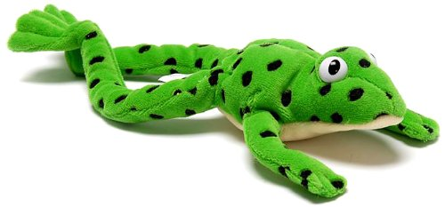

Your child will begin their journey in phonics, following the Read Write Inc. scheme. They will begin to learn single letter sounds and how to write the letter for each sound. We will learn how to put these sounds together to read words. You can help at home by looking for letters in books, sharing stories together, singing songs and nursery rhymes, practising our letter sounds and how to write these letters and making sure your child can read and write their own name. Please write about things you do together in your child’s yellow reading diary and when you have shared a book together. We enjoy reading these in school.

**Maths**

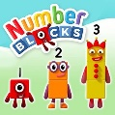During our maths lessons we will play dice games to learn how to subitise (say how many are in a set without counting). We will also develop our counting skills by counting larger sets accurately, saying one number name for each object in the correct order. We will explore the composition of numbers within 5 and compare sets of objects using the language of comparison. We will be able to recognise our numbers and learn how to write them. We will also be able to describe and make patterns and name and describe shapes.

**Curriculum Theme**

This term, the theme for Reception is ‘Marvellous Me.’ We will be finding out about who we are, our own life stories, our likes and dislikes and exploring the natural world around us. We will share lots of stories about school life, families, friendships, feelings and the seasons and learn a range of new songs. We will spend a lot of time learning outdoors so please make sure your child has a coat in school every day. You may also like to send in their own wellington boots to keep at school. Please label these with your child’s name.

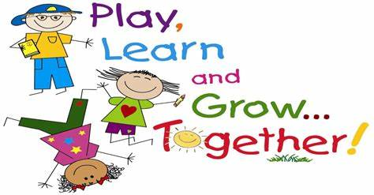**Personal, Social and Emotional Development**

We will focus on making friends and learning new routines in school. we will become familiar with our classroom and school environment and develop our confidence and talk about how we are feeling. We will learn about similarities and differences between us and know that we are all unique and special.

**Understanding the World**

We will talk about our journey to school, things we can see around us and look at and draw maps of our school. We will talk about our families and know our own life story and look at images of familiar situations in the past. We will explore the natural world around us and describe what we can see, hear, and know that there are different countries in the world. We will enjoy exploring the different seasons and notice how things change around us.

**Expressive Arts and Design**

We will enjoy painting and drawing pictures of ourselves, our families and animals using more detail and, when painting these pictures, we will explore colour mixing. We will also explore and join different materials for a desired effect/design and learn and sing a range of songs and nursery rhymes.

**Useful websites**

[www.hightersheath.excelsiormat.org](http://www.hightersheath.excelsiormat.org)

<https://www.bbc.co.uk/cbeebies/shows/numberblocks>

https://www.ruthmiskin.com/parentsandcarers/

**Important Dates for this term**

There are no trips booked for this term in Reception.

**Final Notices!**

**PE day** is **every** **Thursday**. Please ensure that your child has their PE kit in school on those days. Earrings are to be removed or not to be worn on PE days and long hair needs to be tied back.

Homework – we will send out the letter sounds we have been working on in RWI for you to work on together at home. Make sure your child can say the sound and practise writing it on these sheets. Make sure you are sharing lots ot stories together and talk lots about the things you can see around you, things that are important to your child and share with your child what has happened in their, and your day.

If you have any queries, concerns or questions, please do not hesitate to ask. Please phone the school office or email: [enquiry@hightersheath.excelsiormat.org](mailto:enquiry@hightersheath.excelsiormat.org)

I hope that this year will be an exciting, enriching and rewarding year for everybody in Reception and I very much hope that you will join us in helping to make this happen.

Best wishes and thank you in anticipation for your continued support,

Mrs Delves and Mrs Johnson