Spring Term

Dear Parents and Carers,

**Welcome back!**

We hope you all had a lovely break and wish you a very Happy New Year. We have a busy term planned with lots of exciting learning opportunities and new ideas to explore. Reception had an amazing first term at school and made wonderful progress in all areas of their learning. We are very excited to see them continue on their learning journey this term and continue to grow, learn and develop in all that they do. This newsletter contains information about what we will be learning this term. If you have any questions, please feel free to ask, we are here to help.

Mrs Delves and Mrs Johnson.

**English**

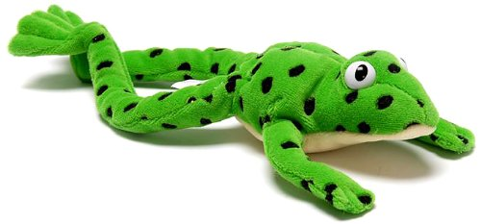

We will continue to develop our phonics knowledge, following the Read Write Inc. scheme. We will ensure we can confidently read and write all of our single letter sounds and the special friends sh, ch, th, qu, ng and nk. We will use these sounds to read and write words more independently and speedily. We will also learn how to sound out words in our head (called ‘Fred in your head’) to read them.

We will continue to explore a range of different stories linked to the themes we are learning and our interests. We will talk about these stories, retell them in our own words, make predictions and use the story language in our play. We will also continue learn a range of new and ambitious vocabulary from books and use this in our everyday conversations.

There will be lots of opportunities for us to write in class and we will work hard to continue to form our letters correctly. We will write simple captions and phrases to match a picture and think about how sentences are constructed starting with a capital letter and ending in a full stop. We will use our phonics knowledge to spell words with increasing accuracy.

**Maths**

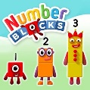In maths, we will know the composition of numbers (how they are made) to 10 and know number bonds to 5 and some number bonds to 10. We will be able to say how many objects are in set to 5 without needing to count them and be able to share sets equally. We will confidently use the language of more and fewer to compare sets and know what is one more / less than a given number. We will continue to talk about what we can see and notice, recognise and create patterns and use a wider range of mathematical vocabulary.

During our work on shape, we will be able to name 2D and 3D shapes and talk about their basic properties. We will also know and use the language related to time and capacity.

**Curriculum Theme**



This term, the theme for Reception is ‘Growing and Changing.’ We will be looking at how we have changed, observing the changes of the seasons, and looking at differences between animals. We will enjoy planting seeds and watching them grow, learning about baby animals and visiting Attwell Farm.

**Personal, Social and Emotional Development**

During this term, we will be learning to understand and talk about the importance of a healthy lifestyle. We will know that we are all unique, special, and important and we will begin to show that we can be resilient and persevere.

**Understanding the World**

We will look at the changes in the seasons and observe and discuss the changes we can see in our environment. We will look at animal habitats and sort and categories animals into where they live.

During winter, we will explore freezing and melting and look at animals life cycles during the spring.

We will think about how we have changed since we were babies and show concern for living things.

**Expressive Arts and Design**

We will enjoy painting and drawing pictures of different animals with increased accuracy and detail and creating winter and spring pictures and collages. We will enjoy telling our own stories, making puppets and learning to sing a range of different songs.

**Useful websites**

[www.hightersheath.excelsiormat.org](http://www.hightersheath.excelsiormat.org)

[www.ruthmiskin.com](http://www.ruthmiskin.com)

[www.bbc.co.uk/cbeebies/shows/numberblocks](http://www.bbc.co.uk/cbeebies/shows/numberblocks)

**Important Dates for this term**

Reception will be visiting Attweel Farm on Thursday 3rd April.

**Final Notices!**

**PE day** is on **Thursday**. Please enure that your child has their PE kit in school on this day. Earrings are to be removed or not to be worn on PE days and long hair needs to be tied back.

Homework – Please make sure that the children read each week and watch the phonics videos that are sent home.

If you have any queries, concerns or questions, please do not hesitate to ask. Please phone the school office or email: [enquiry@hightersheath.excelsiormat.org](mailto:enquiry@hightersheath.excelsiormat.org)

I hope that this year will be an exciting, enriching and rewarding year for everybody in Reception and I very much hope that you will join us in helping to make this happen.

Best wishes and thank you in anticipation for your continued support,

Mrs Delves and Mrs Johnson