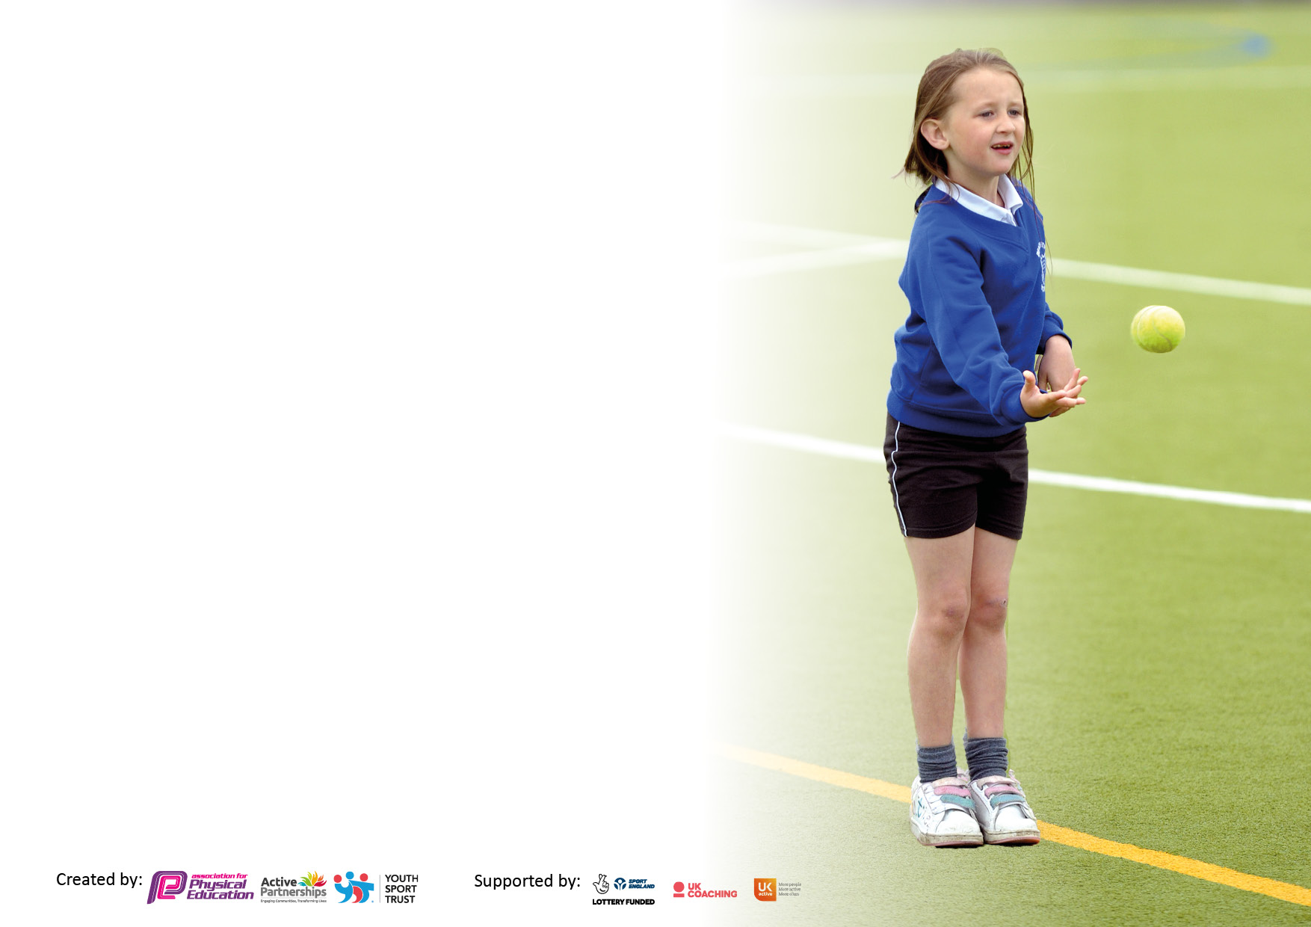

It is important that your grant is used effectively and based on school need. The [Education Inspection Framework](https://www.gov.uk/government/publications/education-inspection-framework) makes clear there will be a focus on **‘whether leaders and those responsible for governors all understand their respective roles and perform these in a way that enhances the effectiveness of the school’**.

Under the Quality of Education judgement, Ofsted inspectors consider:

**Intent** - Curriculum design, coverage and appropriateness

**Implementation** - Curriculum delivery, teaching (pedagogy) and assessment

**Impact** - Attainment and progress

To assist schools with common transferable language, this template has been developed to utilise the same three headings which should make your plans easily transferable between working documents.

Schools must use the funding to make additional and sustainable improvements to the quality of Physical Education, School Sport and Physical Activity (PESSPA) they offer. This means that you should use the Primary PE and sport premium to:

* Develop or add to the PESSPA activities that your school already offers
* Build capacity and capability within the school to ensure that improvements made now will benefit pupils joining the school in future years
* The Primary PE and sport premium should not be used to fund capital spend projects; the school’s budget should fund these.

Please visit <https://www.gov.uk/guidance/pe-and-sport-premium-for-primary-schools> for the revised DfE guidance, including the 5 key indicators across which schools should demonstrate an improvement. This document will help you to review your provision and to report your spend. DfE encourages schools to use this template as an effective way of meeting the reporting requirements of the Primary PE and Sport Premium.

We recommend you start by reflecting on the impact of current provision and reviewing the previous spend.

Schools are required to publish details of how they spend this funding, including any underspend from 2021/2022, as well as on the impact it has on pupils’ PE and sport participation and attainment.

We recommend regularly updating the table and publishing it on your website throughout the year. This evidences your ongoing self-evaluation of how you are using the funding to secure maximum, sustainable impact. Final copy must be posted on your website by the end of the academic year and no later than the 31 July 2023.

**Details with regard to funding**

Please complete the table below.

|  |  |
| --- | --- |
| Total amount carried over from 2023/24 | £0 |
| Total amount allocated for 2024/25 | £17,800 approx |
| How much (if any) do you intend to carry over from this total fund into 2024/25? | £0 |
| Total amount allocated for 2024/25 | £17,800 approx |
| Total amount of funding for 2024/25 to be reported on by 31st July 2025 | £ 17,800 approx |

**Swimming Data**

Please report on your Swimming Data below.

|  |  |
| --- | --- |
| Meeting national curriculum requirements for swimming and water safety.  **N.B.** Complete this section as best you can. For example, you might have practised safe self-rescue techniques on dry land which you can then transfer to the pool when school swimming restarts.  **Due to exceptional circumstances priority should be given to ensuring that pupils can perform safe self-rescue even if they do not fully meet the first two requirements of the NC programme of study** | 2023/24 |
| What percentage of your current Year 6 cohort swim competently, confidently and proficiently over a distance of at least 25 metres?  **N.B.** Even though your pupils may swim in another year, please report on their attainment on leaving primary school at the end of the summer term 2023.  Please see note above | 29% |
| What percentage of your current Year 6 cohort use a range of strokes effectively [for example, front crawl, backstroke and breaststroke?  Please see note above | 64.5% |
| What percentage of your current Year 6 cohort perform safe self-rescue in different water-based situations? | 58% |
| Schools can choose to use the Primary PE and sport premium to provide additional provision for swimming, but this must be for activity **over and above** the national curriculum requirements. Have you used it in this way? | Yes/No |

**Action Plan and Budget Tracking**

Capture your intended annual spend against the 5 key indicators. Clarify the success criteria and evidence of impact that you intend to measure to evaluate for pupils today and for the future.

|  |  |  |  |  |
| --- | --- | --- | --- | --- |
| **Academic Year:** 2023/24 | **Total fund allocated:** | **Date Updated:** | |  |
| **Key indicator 1:** Increase confidence, knowledge and skills of all staff in teaching PE and sport | | | | Percentage of total allocation: |
| % |
| **Intent** | **Implementation** | | **Impact** |  |
| Your school focus should be clear on what you want the pupils to know and be able to do. What do they need to learn and to consolidate through practice: | Make sure your actions to achieve are linked to your intentions: | Funding allocated: | Evidence of impact:  What do pupils now know and what can they now do? What has changed? | Sustainability and suggested next steps: |
| Continuing to develop OPAL Outdoor, Play and Learning.  2 x 1 hour PE lessons to be delivered each week. | This will continue to increase active participation and engagement in outdoor activity. More children will be active and want to be outside at lunchtime. Accredited OPAL mentor to continue to work with the school  Children will receive 2 hours of physical activity in PE lessons each week plus their breaktimes. Staff are able to deliver lessons using the GETSET4 PE curriculum and have the support from the sports apprentice. | £5500 approx |  |  |
| **Key indicator 2:** The engagement of all pupils in regular physical activity – Chief Medical Officers’ guidelines recommend that  primary school pupils undertake at least 30 minutes of physical activity a day in school | | | | Percentage of total allocation: |
| % |
| **Intent** | **Implementation** | | **Impact** |  |
| Your school focus should be clear on what you want the pupils to know and be able to do. What do they need to learn and to consolidate through practice: | Make sure your actions to achieve are linked to your intentions: | Funding allocated: | Evidence of impact:  What do pupils now know and what can they now do? What has changed? | Sustainability and suggested next steps: |
| Sports Day for all children.  Sports Apprentice  Quality Mark: School Games Bronze/Silver | All children to take part in sports day and are encouraged to take part.  Continue to develop the confidence, skills and knowledge of the sports apprentice. (MAT PE Lead)  Work with MAT PE lead to achieve the Bronze quality mark for school games. | £0  £0 |  |  |

|  |  |  |  |  |
| --- | --- | --- | --- | --- |
| **Key indicator 3:** The profile of PE and sport is raised across the school as a tool for whole school improvement | | | | Percentage of total allocation: |
| % |
| **Intent** | **Implementation** | | **Impact** |  |
| Your school focus should be clear on what you want the pupils to know and be able to do. What do they need to learn and to consolidate through practice: | Make sure your actions to achieve are linked to your intentions: | Funding allocated: | Evidence of impact:  What do pupils now know and what can they now do? What has  changed? | Sustainability and suggested next steps: |
|  |  |  |  |  |
|  |  |  |  |  |
|  |  |  |  |  |
|  |  |  |  |  |
| Apprentice to deliver 4 after school sport-based clubs every week.  Apprentice to work alongside teaching staff to improve the quality of teaching and learning so that it is never less than good.  Ensure there are sufficient resources to ensure curriculum and lunchtime physical activity is well planned and delivered by staff MAT PE lead to design curriculum map.  GetSet4 PE scheme is embedded. CPD support is available online as part of the scheme. | Apprentice is able to choose a range of sports to deliver as after school clubs and these can be offered across both key stages.  Apprentice is able to deliver more lessons confidently. PE MAT lead to continue to support and develop the sports apprentice’s role.  Audit of school resources Audit of school resources to make sure school has the equipment to effectively teach the PE Curriculum.  Staff are aware of the curriculum planner and the CPD support available to them. Curriculum map will ensure we are providing a broad and balanced program which meets the requirements of the national curriculum | £1000approx  £300 |  |  |
| **Key indicator 4:** Broader experience of a range of sports and physical activities offered to all pupils | | | | Percentage of total allocation: |
|  |
| **Intent** | **Implementation** | | **Impact** |  |
| Your school focus should be clear on what you want the pupils to know and be able to do. What do they need to learn and to consolidate through practice: | Make sure your actions to achieve are linked to your intentions: | Funding allocated: | Evidence of impact:  What do pupils now know and what can they now do? What has  changed? | Sustainability and suggested next steps: |
|  |  |  |  |  |
|  |  |  |  |  |
|  |  |  |  |  |
|  |  |  |  |  |
| KDDK teacher to come to support CPD lessons and run and after school club in the Autumn term.  Sports apprentice to offer 3 after school clubs per week | CPD support delivered by professional dance company to improve teaching staff’s knowledge and confidence in teaching- gymnastics and dance. Gymnastics- Autumn 1 and Dance- Autumn 2  After school Gymnastics Club  After school Dance Club  3 after school clubs -range of different sports offered to both key stages each week- change each term/half term | 14 weeks £37 per hour (2 per week)  £1036  14 x £32 = £448  £0 |  |  |

|  |  |  |  |  |
| --- | --- | --- | --- | --- |
| **Key indicator 5:** Increased participation in competitive sport | | | | Percentage of total allocation: |
| % |
| **Intent** | **Implementation** | | **Impact** |  |
| Your school focus should be clear on what you want the pupils to know and be able to do. What do they need to learn and to consolidate through practice: | Make sure your actions to achieve are linked to your intentions: | Funding allocated: | Evidence of impact:  What do pupils now know and what can they now do? What has  changed? | Sustainability and suggested next steps: |
|  |  |  |  |  |
|  |  |  |  |  |
|  |  |  |  |  |
|  |  |  |  |  |
| Increased participation in competition raises profile of sport and PE. Achievement are celebrated by School.  MAT Olympic Sports Day at KES | Enrolment into local school sports partnership. Events organised across between local schools and across the MAT.  Travel to other school using partnership transport where appropriate but allocated £1000 for non-use of mini-bus.  Winning teams from Sports Day to attend whole MAT event | £600 approx  £1000 |  |  |

|  |  |
| --- | --- |
| Signed off by | |
| Head Teacher: | J.Aulton |
| Date: | 11.7.24 |
| Subject Leader: | B.Wilson |
| Date: | 9.7.24 |
| Governor: |  |
| Date: |  |