Autumn Term

Dear Parents and Carers,

**Welcome back!**

We would like to welcome year 1 back to school this year, they have started their year amazingly! I would like to introduce myself; I am Mrs Wright, and I am the Year 1 class teacher, the teaching assistant in Year 1 is Mrs Sidwell-Brittle. We have already had the most amazing start to the year, and we know that this is going to be a fantastic year with lots of wonderful learning opportunities ahead of us. We would both like to say how well the children have settled, it is lovely to see them all coming into school ready for learning, looking so smart in their school uniform. We are all very excited for the year ahead.

**English**

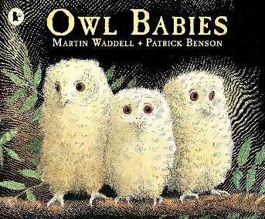We are starting our English learning journey this year with the story “Owl Babies”. This is a wonderful story about three baby owls that lose their mother, and their journey to getting her back and supporting each other.

We have been reading the story and delving into what makes it such a good book! We are going to start our writing journey by thinking about how to write a letter to someone. The end outcome of our learning this half term is going to be a letter written to the mother owl from one of her owl babies, we are excited to see the outcome of our letters!

The children’s library day this half term is going to be Thursday. The children will choose a book that they would like to bring home and then they will return it the next week in order to change it for another book. Please make sure you read with your child each week at home; it is very important! Your child will be bringing home two Read Write Inc phonics books that we will change each week as we learn the stories in class. Please ensure that you write in their home reading diary so that we know they have been reading at home, thank you!

**Maths**

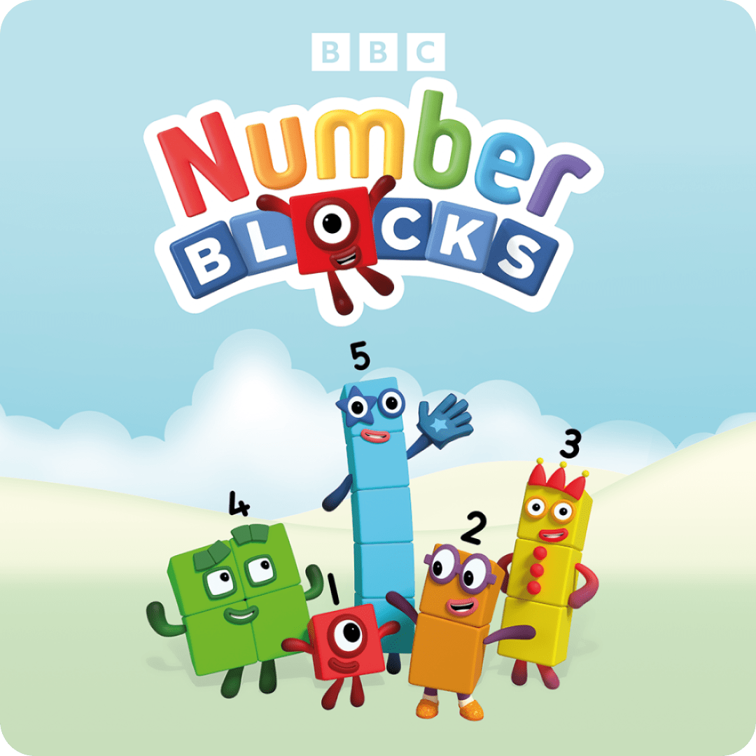In Year 1 we have maths two times a day. We do maths no problem in the morning and then mastering number each afternoon. In our morning maths we are focusing on the numbers 1-10, and we are thinking about how each number can be made, while also focusing on counting accurately. We will soon move on to number bonds within 10 so that we can gain a deeper understanding of how to make and use numbers. After this we are moving on to simple addition and subtraction within 10 to start to consolidate those skills. In mastering number each afternoon, we use a range of concrete resources to become speedy mathematicians, and to enable us to be able to talk about number facts.

**Curriculum Theme**

Our theme in Year 1 this half term is “What is a map?” We have already sent home the knowledge organiser for this theme, and it tells you all about our learning. There are also home learning projects that we encourage you to have a go at home, if you bring them in, we can celebrate them in class! We will be looking at different types of maps, while also having a go at drawing and making our own. We will learn compass points and explore globes and atlases. We will learn all about map keys and what the symbols mean, we started our learning by looking at a bird's eye view of our school and this was an exciting start!

**Other subjects at a glance:**

Each afternoon we will be teaching a range of other subjects: computing, music, science and PE.

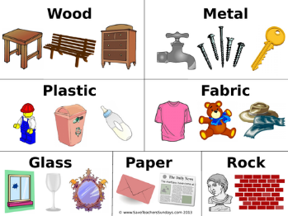In science we are learning about everyday materials and their properties. We are learning the names of materials and will then do a range of experiments to test their properties, for example: are they waterproof? Which ones can be recycled together? Which is the strongest material? We will learn about why each material was made and how we use them on our planet.

In computing we are learning about computer systems and networks. We are starting our learning journey by learning about mouse skills, logging in and how to use different programmes to create pictures. At the end of this year's learning journey, we will produce a picture story using technology.

In music we are using the Charanga scheme, this terms focus song is called “Hey you!”, while doing music the children will start to learn about rhythm and pulse and how to check which instruments are in a song. We will play games and learn the lyrics to songs and then showcase what we have been learning at the end of the term by performing our song.

In PE this term we are focusing on two different aspects of physical education, these are: dance and gymnastics. In dance we are learning about the four seasons, and we will produce a dance to showcase each season. Every Wednesday we are doing gymnastics, and we are lucky enough to have a gymnastics coach that comes into school to teach us, we are doing so well so far!

**Useful websites**

[www.hightersheath.excelsiormat.org](http://www.hightersheath.excelsiormat.org)

[www.ruthmiskin.com](http://www.ruthmiskin.com)

[www.phonicsplay.com](http://www.phonicsplay.com)

[www.bbc.co.uk/cbeebies/shows/numberblocks](http://www.bbc.co.uk/cbeebies/shows/numberblocks)

**Important Dates for this term**

There are no trips booked for this term in Year 1.

**Final Notices!**

**PE days** are **Monday** and **Wednesday**. Please ensure that your child has their PE kit in school on those days. Earrings are to be removed or not to be worn on PE days and long hair needs to be tied back.

Homework – Please make sure that the children read each week and watch the phonics videos that are sent home.

If you have any queries, concerns or questions, please do not hesitate to ask. Please phone the school office or email: [enquiry@hightersheath.excelsiormat.org](mailto:enquiry@hightersheath.excelsiormat.org)

I hope that this year will be an exciting, enriching and rewarding year for everybody in Year 1 and I very much hope that you will join us in helping to make this happen.

Best wishes and thank you in anticipation for your continued support,

Mrs Wright and Mrs Sidwell Brittle