Autumn Term

Dear Parents and Carers,

**Welcome back!**

We are so excited to see all of our families again and to start a brand new school year together! Already we have completed some superb learning within our class and your children have made a great start to Year 2. I am Mrs Cooke, and I have the pleasure of teaching alongside Miss Morris, our Year 2 teaching assistant. Mrs Lindsay will also teach in Year 2 on a Friday morning. We can’t wait to get to know both yourselves and your children this year.

We are sure it’s going to be a fantastic time full of learning, laughter, and great memories. Let's make this year the best one yet!

**English**

The majority of the class are taking part in the Read Write Inc phonics programme, with the support of our amazing phonics team. On completion of the phonics programme, the children will join whole class reading sessions, which are designed to inspire a love of various genres and text types. We look at a new text each week and take the time to learn new vocabulary, compare authors work and respond to a deeper question that pushes the children to look beyond the text. Children will bring home either phonics books or library books depending on their stage of learning. It is vital that the books are read, and diaries signed to be checked.

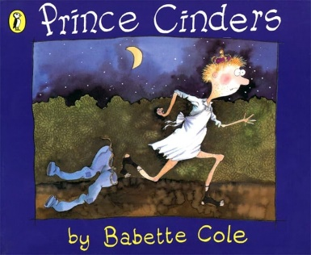Our library day is **Friday.**

In our writing, we are using the story of Prince Cinders, a modern retelling of Cinderella, to structure our work. After looking at different sentence structures, engaging in descriptive writing and refining our SPAG skills, the children will be retelling the tale in their own words. We are also following the Letterjoin scheme for handwriting and using Spelling Shed to learn weekly spelling rules.

**Maths**

In maths we have just completed our work with Numbers to 100, where we looked at the importance of writing our digits in the correct place, comparing two-digit numbers using inequality symbols, spotting number patterns, partitioning in different ways and much more! We are about to move on to addition and subtraction, which will build on our place value work and encourage the children to consider different methods of adding and subtracting, in order to find the most efficient way.

We also do daily Mastering Number to refresh our math skills and reinforce our learning, alongside TT Rockstars, which helps our fluency in times tables.

**Curriculum Theme**

Our curriculum theme this term is Transport and Travel, in which we hope to answer; ‘How has transport developed through history and changed people’s everyday lives?’ The children have already done a fantastic job at discussing how we travel today and were thoroughly engaged in learning about the process of import and export. Our trip to Coventry Transport Museum on the 17th October will also help us to physically see how transport has changed over time.

There is nothing we love more in Year 2 than seeing the children’s passion projects from home. The knowledge organisers about our unit of work have been sent home already and offer a brilliant list of potential homework ideas. We would love to see the wonderful work inspired by this theme!

**Other subjects at a glance:**

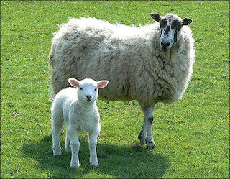

Science – Animals Including Humans

Music – Hands, Feet, Heart– Charanga Scheme

RE- Living by Rules

Personal Development- Relationships

PE- Gymnastics and Dance

Computing-Computing systems and networks: Using a computer

**Useful websites**

[www.hightersheath.excelsiormat.org](http://www.hightersheath.excelsiormat.org)

[Times Tables Rock Stars – Times Tables Rock Stars (ttrockstars.com)](https://ttrockstars.com/)

**Important Dates for this term**

Thursday 17th October-Coventry Transport Museum

Please return the consent forms to either the office or to a member of the Year 2 team as soon as possible please.

**Final Notices!**

**PE day** is **Wednesday** and **Thursday**. Please ensure that your child has their PE kit in school on those days. Earrings are to be removed or not to be worn on PE days and long hair needs to be tied back.

Homework – Each week the children will bring home a piece of spelling homework, their reading book and a times table sheet.

If you have any queries, concerns or questions, please do not hesitate to ask. Please phone the school office or email: [enquiry@hightersheath.excelsiormat.org](mailto:enquiry@hightersheath.excelsiormat.org)

I hope that this year will be an exciting, enriching and rewarding year for everybody in Year 2 and I very much hope that you will join us in helping to make this happen.

Best wishes and thank you in anticipation for your continued support,

Mrs Cooke and Miss Morris