Spring Term

Dear Parents and Carers,

**Happy New Year!**

We hope you had a lovely break filled with festive fun! We are so excited to welcome the children back into class and start 2025 off in the best way possible. After a full term of learning we have had the pleasure of getting to know the children well and what a brilliant Year 2 class we have! Spring term is sure to be just as amazing as the last.

**English**

Just under half of the class are working towards the completion of the Read Write Inc phonics programme, with the support of our amazing phonics team. Most of Year 2 are now part of our class reading sessions. We still look at a new text each week and, during Autumn term, we really pushed the boundaries of literature! From Rudyard Kipling to Roald Dahl, classic poetry to recipes, the children have met each new text with great enthusiasm.

Children will still bring home either phonics books or library books depending on their stage of learning. Please can we ask that the books are read at home and signed as part of their homework. This will be checked weekly.

We also now have a 10-minute phonics refresher session, twice weekly, for added practise.

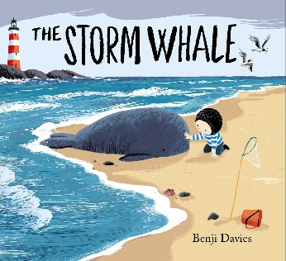Our library day is **Friday.**

In our writing, we are using the story of The Storm Whale as our stimulus. It is a heartwarming book about a little boy, who rescues a beached whale and finds more than he expected. After looking at different sentence structures, engaging in descriptive writing and refining our SPAG skills, the children will be changing the characters to create their own finding tale. We are also continuing with the Letter-Join scheme for handwriting and Spelling Shed to learn weekly spelling rules.

**Maths**

In maths we are beginning to learn about mass, in the context of kilograms and grams. The class will learn how to read a scale, to compare the weight of different objects and to solve word problems relating to mass. Following this, Year 2 will move on to look at temperature and pictograms.

We also do daily Mastering Number to refresh our math skills and reinforce our learning, alongside TT Rockstars, which helps our fluency in times tables.

**Curriculum Theme**

Our curriculum theme this term is ‘Town and Country’, in which we hope to answer; ‘What is similar and different between different settlements (cities, towns and villages)?’ The children have already made such great progress in the topic, learning the difference between densely and sparsely populated areas, the differences and similarities between settlements, and why people may choose to settle in one place over another.

There is nothing we love more in Year 2 than seeing the children’s passion projects from home. The work we received last term were super and all had pride of place on our learning wall. The knowledge organisers for this unit of work were sent home last term and offer some great potential homework ideas. We would love to see the wonderful work inspired by this theme!

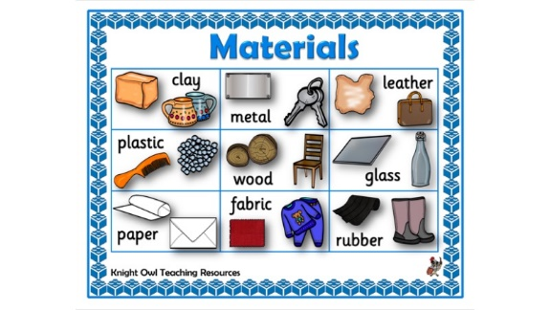**Other subjects at a glance:**

Science – Use of Everyday Materials

Music – I Wanna Play in a Band– Charanga Scheme

RE- Creating Unity and Harmony



Personal Development- Living in the Wider World

PE- Fitness and Net and Wall Games

Computing-Computing systems and networks: Word Processing

Art- Exploring Watercolour-Access Art Scheme

**Useful websites**

[www.hightersheath.excelsiormat.org](http://www.hightersheath.excelsiormat.org)

[Times Tables Rock Stars – Times Tables Rock Stars (ttrockstars.com)](https://ttrockstars.com/)

**Important Dates for this term**

Visit to Christ Church- Date to be confirmed

**Final Notices!**

**PE day** is **Thursday and Friday**. Please ensure that your child has their PE kit in school on those days. Earrings are to be removed or not to be worn on PE days and long hair needs to be tied back.

Homework – Each week the children will bring home a piece of spelling homework, their reading book and a maths sheet.

If you have any queries, concerns or questions, please do not hesitate to ask. Please phone the school office or email: [enquiry@hightersheath.excelsiormat.org](mailto:enquiry@hightersheath.excelsiormat.org)

We have no doubt that Year 2 will have a fantastic year filled with exciting new learning and experiences.

Best wishes and thank you for your continued support,

Mrs Cooke and Miss Morris