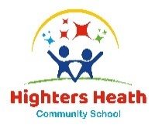

Spring Term

Dear Parents and Carers,

Welcome back!

We would like to welcome Year 3 back to school and hope you all had a wonderful break. We have already had the most amazing start to the year, and we know that the upcoming terms are going to be fabulous with lots of wonderful learning opportunities ahead of us. It has been lovely to see how well all the children have settled and how well they come into school each day, ready for learning. We are all very excited for this term.
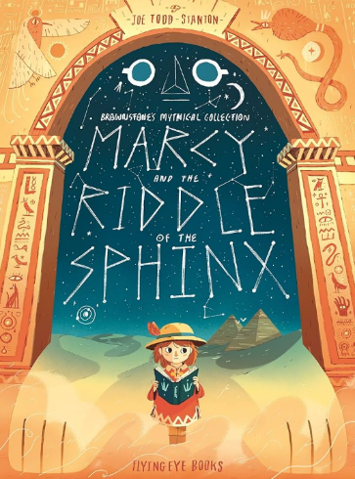
English
In our English lessons this half term we are using the story of Marcy and the Riddle of the Sphinx. This book is about a young girl who goes on an adventure in Ancient Egypt. We will begin by continuing the story together, once Marcy has returned home. For our independent writing, we will rewrite her quest but will be innovating the dilemma.

The children’s library day will be on a Friday. Please ensure that your child is reading at home and that reading diaries are signed and returned each week, ready to be checked and changed.

Maths
In our morning maths lessons, we are focusing on multiplication and division. This includes multiplying and dividing by 3, 4 and 8. We will then move onto multiplying by 2 digits and multiplying and dividing with renaming.
During the afternoon we will do our daily TT RockStars times tables practise, as well as Mastering Number where we focus on number facts in order to become speedier mathematicians.

Curriculum Theme
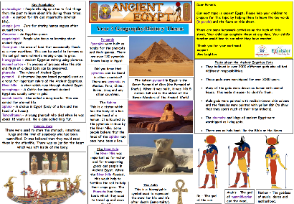
For the first part of this term will be continuing our theme of Ancient Egypt. Throughout this exciting History unit, we will be learning all about Ancient Egyptian society, their Gods, the pyramids and the importance of the River Nile. We have already sent out the knowledge organisers for this theme and have already received some wonderful home learning projects. It would be great if we could have even more, then we can celebrate them in class! After we’ve finished this theme, we will be moving onto learning all about Birmingham in our Geography theme.

Other subjects at a glance:
Each afternoon we teach a variety of subjects including computing, PE, science and music. In science we will focus on physics and will be learning all about light. After that, we will be focusing on chemistry and will be learning about rocks.

In our music lessons this year the children are extremely lucky to be working on a project with the Rock It Music Project and will have the opportunity to play a range of instruments, including keyboards and ukeleles.

In our PE lessons this term we are focusing on cricket and yoga. We are very lucky to be working with a coach who will be teaching us yoga each week.

Useful websites

www.hightersheath.excelsiormat.org
Times Tables Rock Stars – Times Tables Rock Stars (ttrockstars.com) – your child’s log in details are in their reading diary.
KS2 - England - BBC Bitesize

Important Dates for this term

Wednesday 12th March 2025 – Year 3 RE visit to the Synagogue.
Thursday 8th May 2025 – Year 3 visit to Birmingham Library.

Final Notices!

PE days are Tuesday and Wednesday. Please ensure that your child has their PE kit in school on those days. Earrings are to be removed or not to be worn on PE days and long hair needs to be tied back.

Homework – times tables practise, and some English homework will be sent out each Friday. Please can this be returned by the following Thursday.

If you have any queries, concerns or questions, please do not hesitate to ask. Please phone the school office or email: enquiry@hightersheath.excelsiormat.org

I hope that the rest of this year will be exciting, enriching and rewarding for everybody in Year 3 and I very much hope that you will join us in helping to make this happen.

Best wishes and thank you in anticipation for your continued support,

Mrs Leighton and Mrs Sharif

