Autumn Term

Dear Parents and Carers,

**Welcome back!**

A big hello from me, Mrs Wilson and Mrs Hussein, Year 4 teaching assistant! Year 4 have settled in well to their new classroom and new routines. I have enjoyed getting to know them, again, over these past few weeks. I hope they continue to work hard and do their best.

**English**

In English, we have been learing all about the great explorer, Ernest Shackleton. We have been reading Shackleton’s journey and have started our writing to entertain

In reading, we have been reading ‘Queen of Darkness’ by Tony Bradman. This fiction text is based on the real life story of Boudica, queen of the Iceni tribe in England, during Roman times.

.

You may like to listen to ‘The Queen of Darkness’ on youtube. It is read chapter by chapter by Mr Pettett.

Next half term, we will be reading…

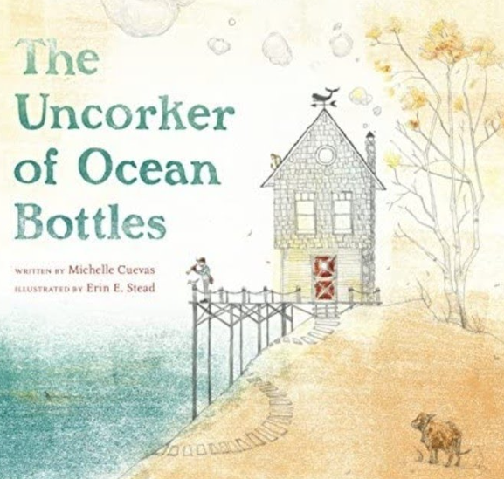

**Maths**

In maths, we are looking at place value to 10,000. We have been looking at the value of numbers and rounding. Next, we will be learning about addition and subtraction within 10,000 and then moving onto multiplication and division.

You may like to log onto TTRocktars to become fluent with your times tables as this will be very important for the Multiplication Check, later in the year.

**Curriculum Theme**

In theme lessons, we have been learning about the Romans. There are lots of different activities you could try out at home, which are listed on the knowledge organiser. You could research about Roman Britain, design a shield or create a painting of a Roman soldier.

**Other subjects at a glance:**

RE- We are looking at how other religions express joy and respect.

Science – Animals including humans

Music – We are working with the music teacher every Tuesday morning.

PD- Health and well-being

Computing- collaborating with others online.

PE- gymnastics and ball skills

**Useful websites**

[www.hightersheath.excelsiormat.org](http://www.hightersheath.excelsiormat.org)

[www.ttrockstars.com](http://www.ttrockstars.com)

[www.topmarks.co.uk](http://www.topmarks.co.uk)

**Important Dates for this term**

Romans workshop: Friday 27th September

**Final Notices!**

**PE day** is **Tuesday** and **Friday**. Please enure that your child has their PE kit in school on those days. Earrings are to be **removed or not to be worn on PE days** and long hair needs to be tied back.

Homework – every Friday, home learning will be sent home. This will be a mixture of English and maths learning we have looked at this week. Reading books will be changed every Monday, so please ensure you have your books in school, ready to change. You may also like to log onto TTRockstars to earn certificates.

If you have any queries, concerns or questions, please do not hesitate to ask. Please phone the school office or email: [enquiry@hightersheath.excelsiormat.org](mailto:enquiry@hightersheath.excelsiormat.org)

I hope that this year will be an exciting, enriching and rewarding year for everybody in Year 4 and I very much hope that you will join us in helping to make this happen.

Best wishes and thank you in anticipation for your continued support,

Mrs Wilson and Mrs Hussein