

Spring Term

Dear Parents and Carers,

Welcome back!

We hope you have had a wonderful Christmas break and enjoyed some well-earned rest with family and friends. We are looking forward to the new term and all of the new learning opportunities this year holds.

English
In our Reading lessons we will be reading Anglo Saxon Boy, a fictional book based on the life of an Anglo Saxon. In the text we meet Magnus, who is the son of Harold Godwinson, lord of the Southern Saxons and ruthlessly ambitious claimant to the throne of England. Overnight, Magnus finds himself cast centre-stage in the blood-soaked family feud that led to one of history's most famous battles.

We will also be reading ‘The Boy at the Back of the Class’. This is the story about how one ordinary nine-year-old child and three classmates are full of empathy for Ahmet, a boy that comes to their school as a refugee from Syria.


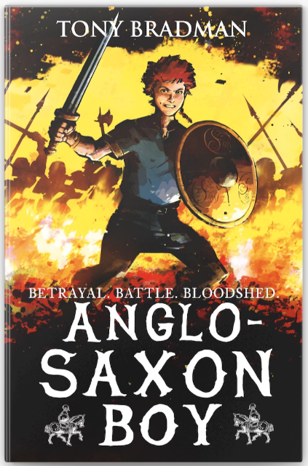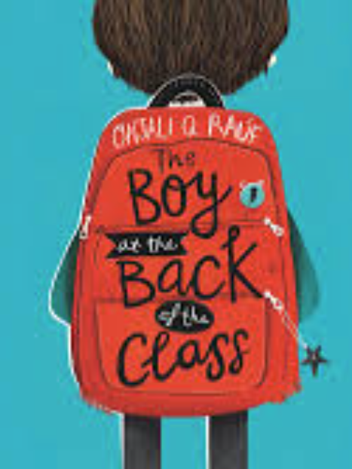
In our English lessons, we will be writing a newspaper article based on a short animation called ‘Spyfox’.

We will also be writing a quest story after reading ‘Journey’ by Aaron Becker. In the text a lonely girl draws a magic door on her bedroom wall and through it escapes into a world full of wonder, adventure and danger. The children will be able to use their imagination to create their own version of the story.

Maths
In maths, we will be continuing to focus on multiplication and division. It is vital that children learn their timestables. Remember to use TTRockstars.com to practice at home as often as possible. We will also be looking at graphs, interpreting data and fractions. You could use www.topmarks.co.uk to help support at home.

Curriculum Theme
In theme, we will be continuing to learn about earthquakes, mountains and volcanoes. We have had lots of amazing powerpoints, drawings and stories bought in from home last year, we look forward to seeing more. We will then be looking at the Normans and their impact on Britain. You could research about who the Normans were and collect information about them. I wonder what it was like to be a Norman?
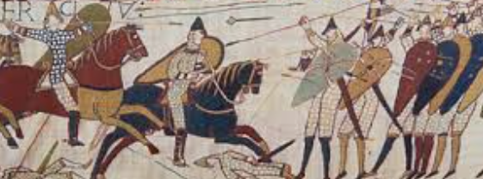
Other subjects at a glance:
In Science, we will be learning about electricity, thinking about circuits and electrical safety.
In Music, we will continue to work with our music teacher and work towards a performance, later in the term.
In RE, we will be learning about forgiveness, belonging and identity.
In our PD lessons, we will be looking at being proud of our differences, being respectful to others and understanding how our choices affect the environment we live in.
In Computing, we will be building websites and working collaboratively. We will learn new skills and research using the internet.
In PE, we will be working with a specialist yoga teacher. We will also be developing our hockey skills, building on what we learned last year in Year 3.

Useful websites

www.hightersheath.excelsiormat.org
www.ttrockstars.co.uk
www.topmarks.co.uk
www.timestables.co.uk

Important Dates for this term

Final Notices!

PE day is Tuesday and Wednesday. Please enure that your child has their PE kit in school on those days. Earrings are to be removed or not to be worn on PE days and long hair needs to be tied back.

Homework
Homework will be sent out each Friday and should be returned by the following Thursday. Homework will consist of spellings we have learned that week and maths linked to the learning we have done that week. Please ensure your child reads at home, to help them build their fluency.

If you have any queries, concerns or questions, please do not hesitate to ask. Please phone the school office or email: enquiry@hightersheath.excelsiormat.org

I hope that this year will be an exciting, enriching and rewarding year for everybody in Year 4 and I very much hope that you will join us in helping to make this happen.

Best wishes and thank you in anticipation for your continued support,

Mrs Wilson

