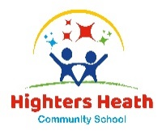

Autumn Term

Dear Parents and Carers,

Welcome back!

We would like to take this opportunity; to welcome you and your children to Year 5 and introduce ourselves to you, I will be their class teacher Miss Vigers and their teaching assistant this year will be Mrs Sharif. We would both like to say how well the children have settled, its lovely to see them all coming in looking so smart and ready for their learning. We are both looking forward to the year ahead and getting to know the children and working with them.

English
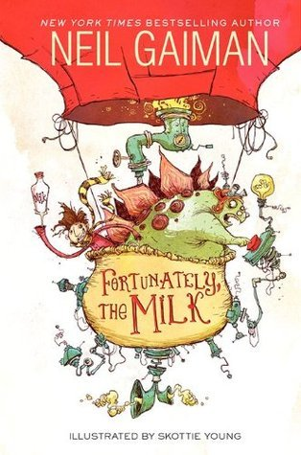
This term in English we are reading ‘Fortunately the Milk’ which is a fun and entertaining, story about a dad who goes to the shop to buy some milk, but it takes him a long time to get home. When he does arrive home, he tells his children the story of what has happened to him and the different characters he meets on his journey.
The story will be a stimulus for Year 5 creative writing where the children will then write their own chapters. This unit will give the children the chance to use their imagination in their writing.
The children’s library day will be on a Thursday so could you please make sure they are reading at home and reading diaries are signed and books returned on a Thursday to be checked and changed.

Maths
This term Year 5 are covering the topics of number and place value, where they will learn to read, write and order numbers, rounding numbers to the nearest multiple of 10, 100 and 1000 as well as using negative numbers in context. They will then progress onto using the knowledge to practice mathematical calculations to apply and solve a variety of problems.

Curriculum Theme

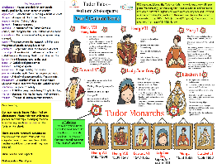
In this unit of work children will be consider the significant part religion has on historical cause and consequence through the Reformation and Henry VIII’s break with Rome and the actions of ‘Bloody Mary’. The children will also learn about Henry VIII’s wives. We will look in detail at key figures during this period i.e. Henry VIII and Elizabeth I and how they are/were interpreted. Year 5 will also learn about the Elizabethan ‘Golden Age’, with world exploration. All children were sent home with a knowledge organiser, can I please make you aware of the homework on the back of the sheet, it would great to see the children taking part and celebrating their efforts in school.

Other subjects at a glance:

Science – In this unit, children will learn about the forces of gravity and how movement of objects can be affected. They will develop their skills in measurement recording and presenting data.
Music – This term the children are extremely lucky to be working on a project with Rock It Music Project and will have the opportunity to perform their achievements at the end of the term.
French – The unit, that the children are learning is about the weather.
PD – We will be following our No Outsiders units starting with caring relationships.

Useful websites

www.hightersheath.excelsiormat.org

KS2 - England - BBC Bitesize

Important Dates for this term

Thursday 7th November – Year 5 visit to Birmingham Mosque

Final Notices!

PE day is Monday and Tuesday. Please ensure that your child has their PE kit in school on those days. Earrings are to be removed or not to be worn on PE days and long hair needs to be tied back.

Homework – what will be sent out on Friday and will be return on Tuesday.

If you have any queries, concerns or questions, please do not hesitate to ask. Please phone the school office or email: enquiry@hightersheath.excelsiormat.org

I hope that this year will be an exciting, enriching and rewarding year for everybody in Year 5 and I very much hope that you will join us in helping to make this happen.

Best wishes and thank you in anticipation for your continued support,

Miss Vigers and Mrs Sharif

