Autumn Term

Dear Parents and Carers,

**Welcome back!**

We would like to welcome Year 6 back to school this year, they have started their year amazingly! I would like to introduce myself; I am Mrs Jones, and I am the Year 6 class teacher. Working with us in Year 6 we have Mr Moffat and Mrs Hussain. We have already had the most amazing start, and we know that this is going to be a fantastic year with lots of wonderful learning opportunities ahead of us. It has been lovely to see how well all the children have settled and have taken on the challenges Year 6 brings. We are all very excited for the year ahead.

**English**

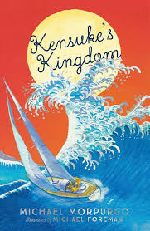We are starting our English journey this year with Kensuke's Kingdom. When Michael's father loses his job, he buys a boat and convinces Michael and his mother to sail around the world. It's an ideal trip - even Michael's sheepdog can come along. It starts out as the perfect family adventure - until Michael is swept overboard. He's washed up on an island. The children will be given the opportunity to develop their narrative writing by writing the next chapter where Michael explores the Island and meets Kensuke.

The children’s library day will be on a Wednesday. It is really important that they are reading at home and that reading diaries are signed and books returned on a Wednesday to be checked and changed.

Spellings will be tested on a Tuesday and new lists will be sent home each week.

**Maths**

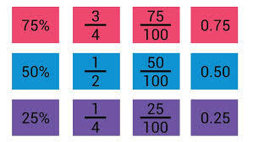Children will begin the term by covering the topics of number and place value, where they will learn to read, write and order 7-digit numbers. We will then move onto rounding numbers to the nearest multiple of 1000, 10 000 and 100 000 and 1 000 000. After that, we will them revisit formal methods for all the four operations before developing our understanding of fractions, percentages and decimals.

**Curriculum Theme**

Our first curriculum theme is World War Two. The children will discover why the war started, who was involved and how people managed to maintain and semi-normal life.

Knowledge organisers have already been sent home which include key information about World War Two that will support children’s learning in school. There are also home learning projects that we encourage you to complete at home. If you bring them in we can celebrate them in class!

**Other subjects at a glance:**



Our science theme is ‘Evolution and inheritance’. The children will explore how offspring inherit characteristics from their parents and how animals and plants have adapted in order to survive.

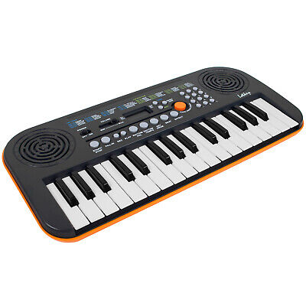

Music – This Year the children are extremely lucky to be working on a project with Rock It Music Project and will get the opportunity to play a range on instruments including keyboards and ukeleles.

**Useful websites**

[www.hightersheath.excelsiormat.org](http://www.hightersheath.excelsiormat.org)

[KS2 - England - BBC Bitesize](https://www.bbc.co.uk/bitesize/levels/zbr9wmn)

**Important Dates for this term**

Wednesday 9th October 2024 at 2:15pm Maths workshop

Year 6 visit to Avoncroft Museum- Date to be confirmed.

Monday 25th November – Year 6 World War Two Workshop

**Final Notices!**

**PE day** is **Monday** and **Tuesday**. Please ensure that your child has their PE kit in school on those days. Earrings are to be removed or not to be worn on PE days and long hair needs to be tied back.

Homework – Maths and Grammar homework will be sent out on a Friday and needs to be returned by Wednesday.

If you have any queries, concerns or questions, please do not hesitate to ask. Please phone the school office or email: [enquiry@hightersheath.excelsiormat.org](mailto:enquiry@hightersheath.excelsiormat.org)

I hope that this year will be an exciting, enriching and rewarding year for everybody in Year 6 and I very much hope that you will join us in helping to make this happen.

Best wishes and thank you in anticipation for your continued support,

Mrs Jones, Mrs Hussein and Mr Moffat